FREE
Adult Cooking Classes
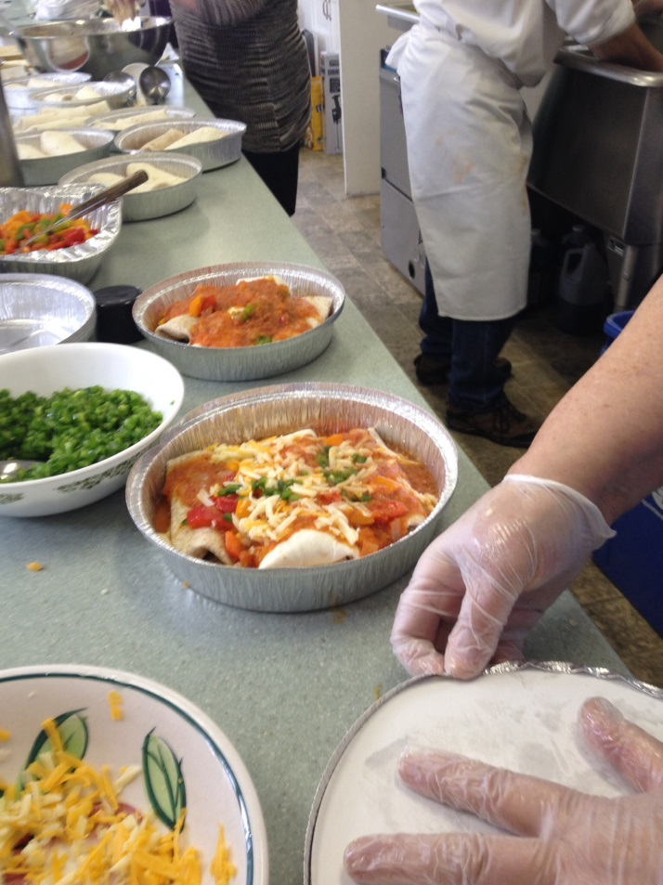
Wellington Essroc Arena 7-9 p.m.
Tuesdays - February 13, 20, 27, March 6
(Limited Registration only 15 Spots Available)
Pre-Register by calling Linda 613-399-1450 or 613-849-7403
or email downeylinda45@gmail.com

